MEHRAN UNIVERSITY

OF ENGINEERING & TECHNOLOGY

JAMSHORO, PAKISTAN

To be able to configure switch using commands

Subject: COMPUTER NETWORKS (PR)

(Lab 5 - Tasks Solution)

|  |  |
| --- | --- |
| **Roll No:** | **22SW028** |
| **Section:** | **I** |

**TASK1.**

**Execute the show version command on CISCO Packet Tracer to answer the following questions:.**

This network is built using a switch and two PCs connected via crossover cable. The switch was configured and tenet was also configured on the switch including the setup of encrypted passwords.

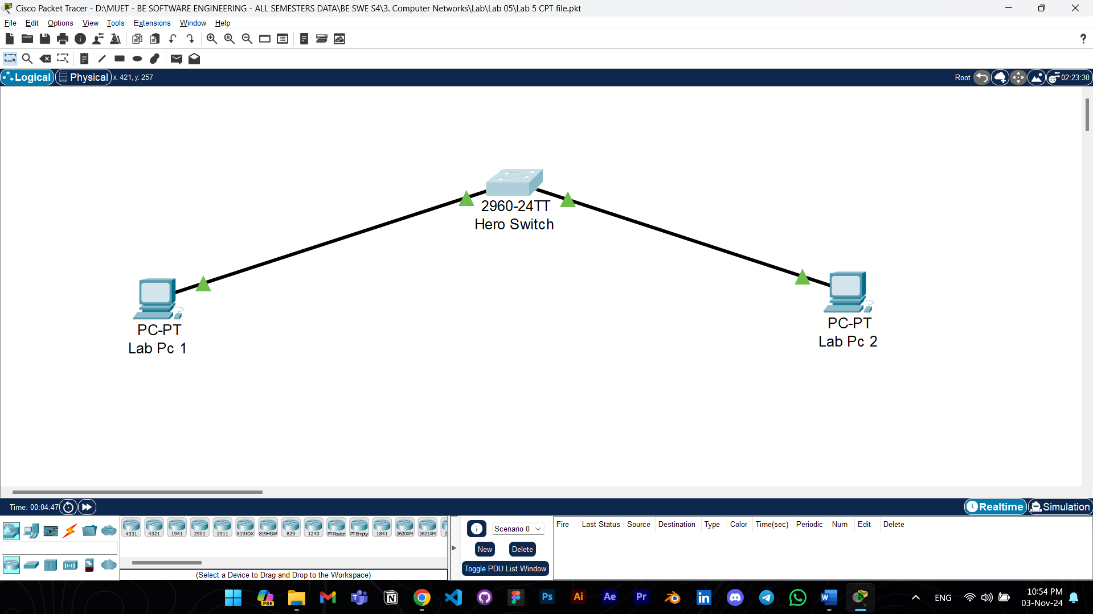

The network was tested via configuring router using Telnet from PC1

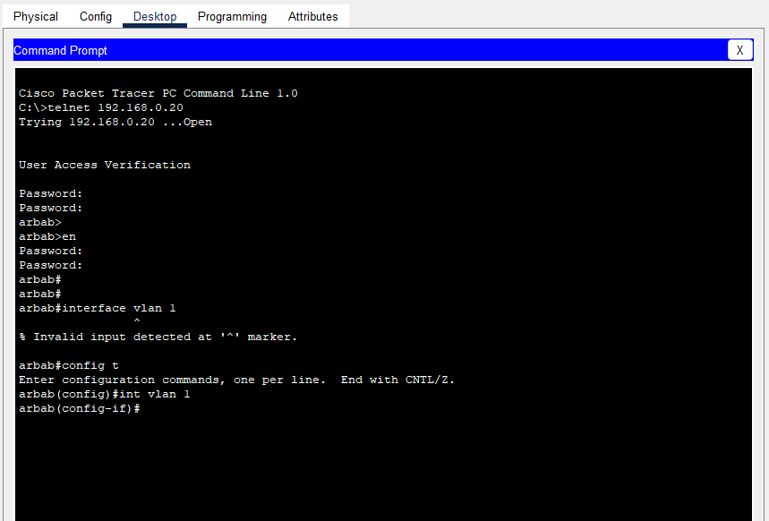

**ANSWER TO THE QUESTIONS:**

1. What is the IOS version?

Ans: 

2. Where was the router IOS image booted from?



3. What type of processor (CPU) and how much RAM does this router have?



4. How many Ethernet interfaces does this switch have?

